W3_T5

Rubie stannard: 103982732

Due: 04 June, 2023
2058 WORDS

ICT20025 ICT DESIGN PROJECT
USER INTERFACE PROJECT REFLECTION

Table of Contents

- Acknowledgement of Country 2
- Overview 3
- Project Deliverables and Experiences 4
- ULO 1 4
- ULO 2 4
- ULO 3 5
- ULO 4 5
- ULO 5 5
- ULO 6 6
- Appendix 7
- ULO 1 7
- ULO 2 9
- ULO 3 10
- ULO 4 11
- ULO 5 12
- ULO 6 13
References 15

1. Acknowledgement of Country
Team 3.5 would like to acknowledge and pay our respects to the Traditional Owners of Australia, the land on which we live, work, and gather. We recognize the rich and enduring presence of Aboriginal and Torres Strait Islander peoples, their cultures, and their deep connection to Australia.
Team 3.5 acknowledges that sovereignty was never ceded and that this land always was and always will be Aboriginal and Torres Strait Islander land. We honour the wisdom, knowledge, and custodianship of Elders past, present.
By acknowledging the Traditional Owners, Team 3.5 strives to promote awareness and recognition of the ongoing struggles, resilience, and contributions of Aboriginal and Torres Strait Islander peoples.

2. Overview
The purpose of this project was to design, analyse and evaluate a user interface prototype made for Gauntlet, which is an online cybersecurity exercise platform designed by Retrospect Labs. Gauntlet was designed to create and deploy custom and premade tabletop and functional exercises that can be run in person or with people online, and capture and analyse the data acquired from completing the cybersecurity exercises.
According to Retrospect Labs, Gauntlet’s user interface is functioning the way it should be, but they’re interested in knowing whether they can make it better. Retrospect Labs identified some ways they think they could make Gauntlet’s user interface better through pains points such as exercise customisation, altering templates for accessibility, and overtime metric benchmarking and tracking. We designed these prototypes to create solutions for the addressed pain points, and to hopefully create a better user interface for Gauntlet.
At the beginning of the semester, I was working in a team. However, in week 7 on the 19th of April I left the team I was working with and became my own team. My contributions to my team included all of the activities completed by myself, so all of the deliverables I’m using as evidence to demonstrate that I have met the unit learning outcomes has been done by me. To support this, I included screenshots of the website permissions that show only I have access, which can be seen in Figure 1 and Figure 2 in the appendix.
The table below shows what evidence I chose to use for the corresponding unit learning outcome. Since I worked on my own, I can’t really provide many experiences, so most of my evidence will be deliverables, with some unit learning outcomes having brief explanations of the experience.
Evidence | ULO1 | ULO2 | ULO3 | ULO4 | ULO5 | ULO6
Deliverable
Experience
Table 1: Summary of deliverables and related ULOs.

3. Project Deliverables and Experiences

3.1. ULO 1
For ULO1, we had to “apply a design thinking approach to understand and solve a stakeholder problem.” This was achieved by using the design thinking process, which is a problem-solving approach that uses 5 stages consisting of empathising, defining, ideating, prototyping, and testing. To demonstrate my knowledge for this ULO, I chose an activity we did for each of the stages.
My deliverable for stage 1 and 2 is Activity 2.1: Empathise and Define – Persona. Screenshots and the link for this activity are Figure 3 in the appendix. The deliverable for stage 3 of the process is Activity 4.2: Ideate – Brainstorm, which can be seen in Figure 4 of the appendix. For a stage 4 deliverable, I chose Activity 5.2: Review and Edit a Figma User Interface Prototype. This deliverable is Figure 5 in the appendix. The last stage of the process is stage 5, and as evidence for this, I included multiple deliverables since we performed testing multiples times throughout the semester. These deliverables include Activity 6.1 and 6.2: Test - Conduct an Inspection and User Evaluation, and Activity 12.1: Project Work where I created a survey for my prototype. These deliverables are Figures 6-8 of the appendix.
I’ll also include my experience with going through the design thinking process as evidence. My evidence is the skills I managed to gain by completing this ULO as it required us to follow the 5 stages of design thinking in order to complete this project. By completing the activities above, and completing the prototype, I was able to understand each stage and how to implement them to the project after completing the activities.
These deliverables relate to ULO1 as they each address a stage of the design thinking process which was important for the process of the project since it provided us with a framework for the project. Through these activities, I was able to understand the needs and desires of the users and address the pain points given by Retrospect Labs.

3.2. ULO 2
Unit learning outcome 2 was “design and implement a project plan using industry standard project management and collaboration tools.” This was achieved by using websites and software such as Confluence, Jira, Figma, and Google Docs. The deliverables for this ULO are Activity 1.1: Get started on Project Proposal and Activity 1.4: Get started on Scrum, which can be seen in Figure 9 and Figure 10, as well as my experience using these tools.
Both of these activities can be used to demonstrate my knowledge and skills related to this ULO because the majority of the project was spent using these tools to design and implement each part of the project. My experience can also demonstrate this. By using the Confluence templates, I was able to make a page for each activity and organise it in a way I think an organisation would. The same can be said for Jira. I was able to use this to create a timeline for the project and manage my progress. Figma was used to create the prototype and was a good website to use as it has a lot of items for free.
My experience using the tools was good since we had access to them for free, they were easy to use, and there were templates available, minimising the time needed to complete activities and the project. I felt like these websites and software had a big impact in the completion of this unit as I wouldn’t have done every activity if I had to manually create a page template or had to use a website that had paid features.

3.3. ULO 3
“Use an analysis of ethical, human and software application context to inform prototype design” is ULO3. Although I don’t completely understand the meaning of this ULO, I’ve provided some deliverables that I feel best demonstrate my knowledge.
The deliverables I chose for this were Activity 2.4: Empathise and Define – User Stories, which is Figure 11 in the appendix, and my finished prototype which was done for Activity 7.1 to 12.1: Project Work, references in Figure 12.
By completing Activity 2.4 I was able to understand what a Gauntlet users’ goals and tasks would be. I was then able to apply my knowledge to a human centred design approach in order to create my prototype. Being able to use a human centred design approach was crucial for the project since the aim of the project was to create a user interface, and by understanding the users’ goals and tasks, we could design an interface that catered to the user.
My prototype didn’t address every pain point identified by Retrospect Labs, and when I was making it, I completely forgot about the user stories I wrote. Although this was an important part of the project, I didn’t learn much from this ULO.

3.4. ULO 4
ULO4 was being able to “effectively communicate project deliverables and artefacts to stakeholders using a variety of communication types and tools.” This was done by contributing to the project deliverables and reflecting on creating and sharing these deliverables with my team and facilitators.
The evidence for this ULO is Figure 13, 14, and 15, three pictures that address the contribution of the deliverables and sharing them. Figure 13 is a picture of the activities that can be found on my Confluence page. Figure 15 is an image of my process and product demonstration assignment being submitted in Canvas, showing that I was able to share the deliverables with the facilitator. Figure 14 is an image of my Jira sprint history, demonstrating my contribution to the project and showing that I know how to share these things if I was with a team.
These deliverables were important to the project as the Confluence page contained activities that would help a team through the project, and the Jira kept track of everything. Sharing my work with the facilitator was important as it allowed them to see what I did, and because the assignments were required.
When I was with a team, some members didn’t share the work they had done, and this created problems as members didn’t know where they were up to in terms of the activities, meaning we spent time doing the work as a group because a member didn’t and wouldn’t share the work. Sharing work in a group project is important since it demonstrates that members are willing to work together and equally contribute in order to complete the project. The lesson I learnt from ULO3 is that teams won’t function is members aren’t effectively communicating with each other.

3.5. ULO 5
“Identify and actively work towards closing project related knowledge gaps by undertaking independent research and up-skilling activities in major discipline” was unit learning outcome 5.
The activities I completed as a way to conduct independent research to close some of my knowledge gaps I had with the project were Activity 2.2: Empathise and Define – Empathy Mapping and Activity 3.4: Conduct a Competitive Analysis. Figure 16 is Activity 2.2, and I completed this to get an idea of the pages I would need to create for my prototype. This helped me close the gap of not knowing where to start for my prototype and not knowing the stages a user would go through to use Gauntlet. Figure 17 is Activity 3.4, and this was an optional activity that involved conducting research of a platform similar to Gauntlet. Doing this activity helped me understand the features Gauntlet might have, and what a cybersecurity exercise platform might look like.
These upskilling activities impacted my prototype in a good way and were an important part of the project as they helped me visually see what my prototype might’ve contained.

3.6. ULO 6
The last ULO involved “describing strategies for developing an inclusive and safe team culture and providing respectful and constructive feedback to team members.” Although I worked alone, my deliverables can demonstrate that I could work in an inclusive, safe team environment, and could provide members with feedback.
As evidence for developing a safe team culture, I chose the roles and responsibilities Confluence template on my page and Activity 1.3: Set up your Team Agreement. The roles and responsibilities page, Figure 18, can demonstrate the I can develop a strategy for inclusive and safe teams by identifying what needs to be done and who needs to do it. Activity 1.3, Figure 19, shows this by setting out an agreement to address what needs to be done and the consequences that occur if the agreement is not upheld. Creating guidelines and roles should be a strategy that can develop a safe team culture since everyone has input and can talk about what they think a role should do or what should be in the agreement.
An image of a peer assessment survey has been included as Figure 20 as it addresses giving/receiving feedback. The peer assessment survey was used for a way to personally reflect and reflect on team members and give feedback about ways to improve their performance.
The last ULO didn’t apply to me that much, but I learnt that even if you think you’re being inclusive and creating a safe team environment, others may not think the same way, or it might not matter if you are, because some members might not care about feedback or changing.

- Appendix
As mentioned in the overview, I completed the project on my own. The first two figures are evidence to my claim as they show that I’m the only one who had access to the Confluence and Jira page. Figure 9 also supports my statement since it shows that I’m the only one who edited the page, which was the same for every page. Even though I started the semester in a team, they barely contributed to the activities or Confluence page, and whatever work they did contribute, I didn’t use it when I created my separate Confluence page.
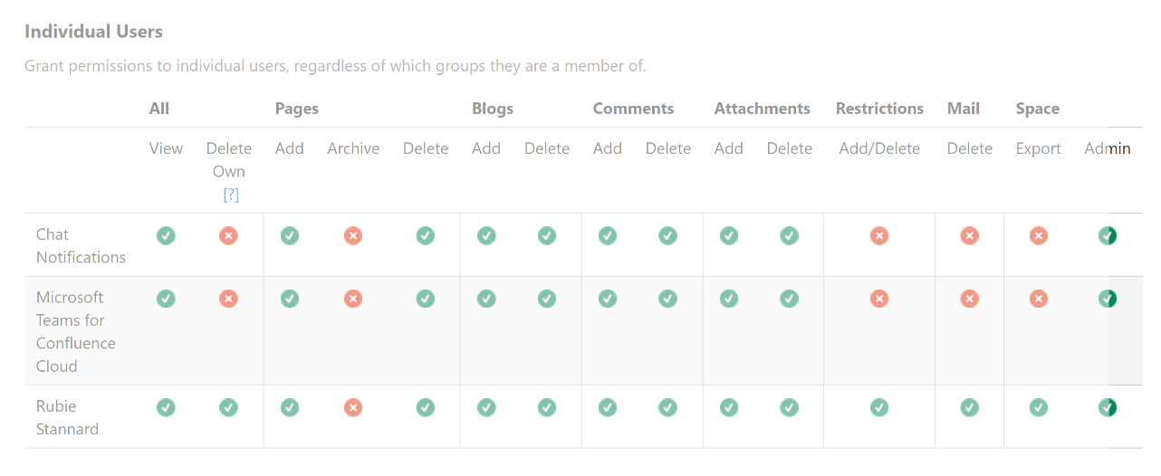
Figure 1: Evidence of my contribution to the creation of the Confluence deliverables.

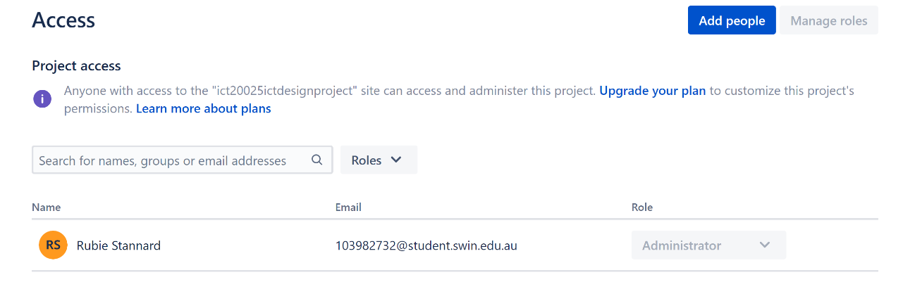
Figure 2: Evidence of my contribution to the creation of the Jira deliverables.

4.1. ULO 1
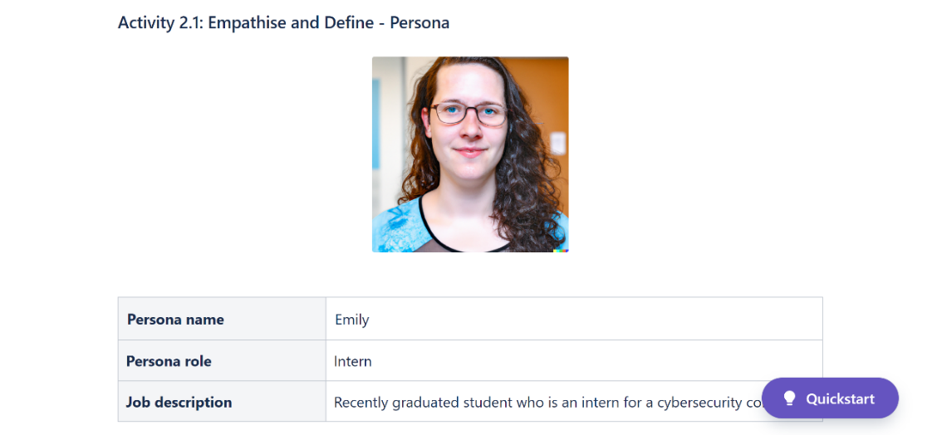
Figure 3: Stannard, R. (2023, May 7). Activity 2.1: Empathise and Define – Persona. Atlassian. https://ict20025designproject.atlassian.net/l/cp/WsJ1YSM5

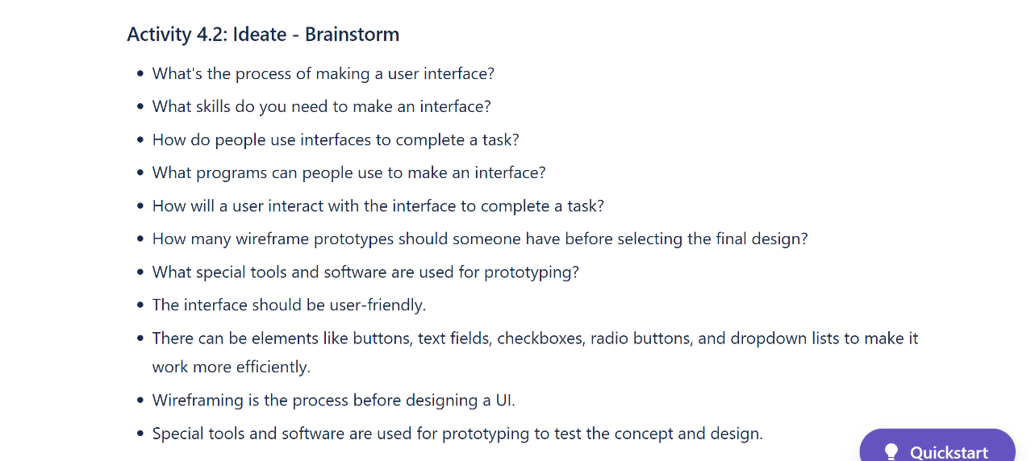
Figure 4: Stannard, R. (2023, May 14). Activity 4.2: Ideate – Brainstorm. Atlassian. https://ict20025designproject.atlassian.net/l/cp/5rtCmqMd

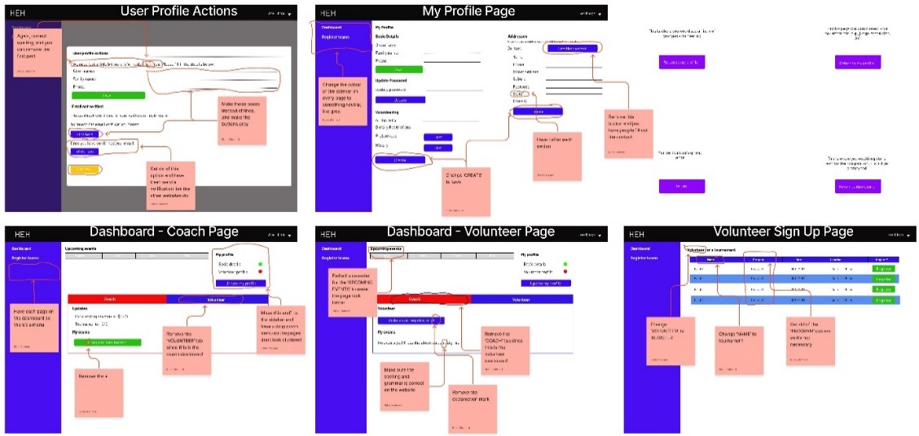
Figure 5: Stannard, R. (2023, May 7). Activity 5.2: Review and Edit a Figma User Interface Prototype. Atlassian. https://ict20025designproject.atlassian.net/l/cp/i0ZQ4b3g

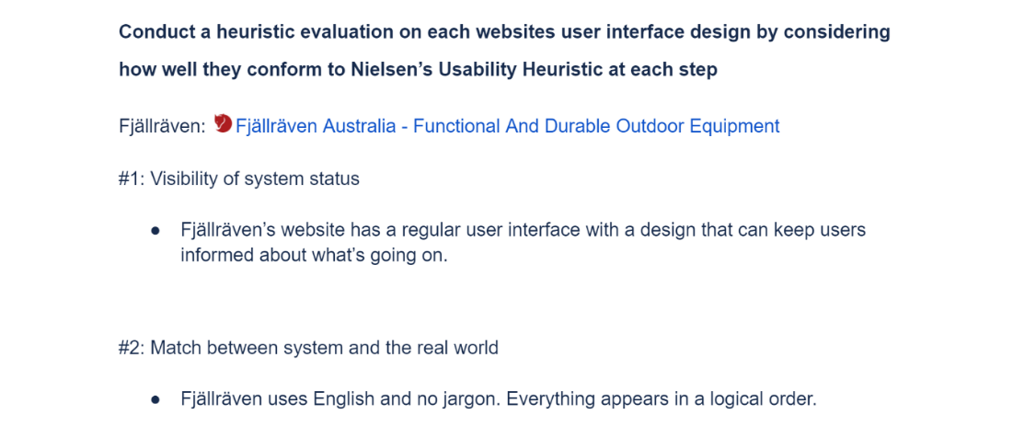
Figure 6: Stannard, R. (2023, May 12). Activity 6.1: Test – Conduct an Inspection Evaluation. Google Docs. https://docs.google.com/document/d/1O43zH6Qrs8ujAt2Za2lIGENTQ9_TmaSv6TqeP1V2084/edit?usp=share_link

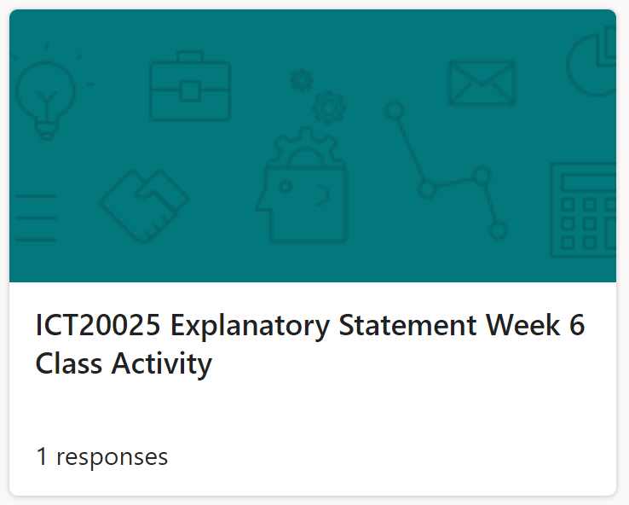
Figure 7: Stannard, R. (2023, May 12). Activity 6.2: Test – Conduct a User Evaluation. Microsoft Forms. https://forms.office.com/Pages/ResponsePage.aspx?id=eXV_35w-fkq4REICgPU4WQWVgij133pDvM49iroUH7ZUOTBFVzAwWjE1VUFMTDlTRTdXN0VSQUZSTi4u

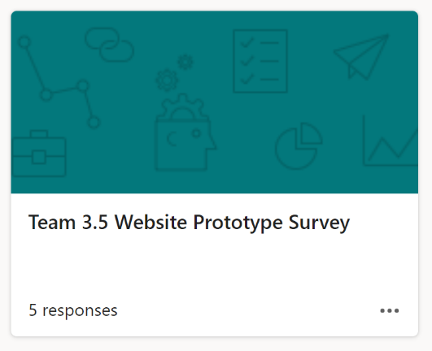
Figure 8: Stannard, R. (2023, May 22). Activity 12.1: Project Work. Microsoft Forms. https://forms.office.com/Pages/ResponsePage.aspx?id=eXV_35w-fkq4REICgPU4WQWVgij133pDvM49iroUH7ZUODdNQlZITDdQVFRCQUZUVUxMNTVPVEtMRy4u

4.2. ULO 2

Figure 9: Stannard, R. (2023, May 12). Activity 1.1: Get Started on Project Proposal (Set Up a Confluence Space). Atlassian. https://ict20025designproject.atlassian.net/l/cp/fzSG216G

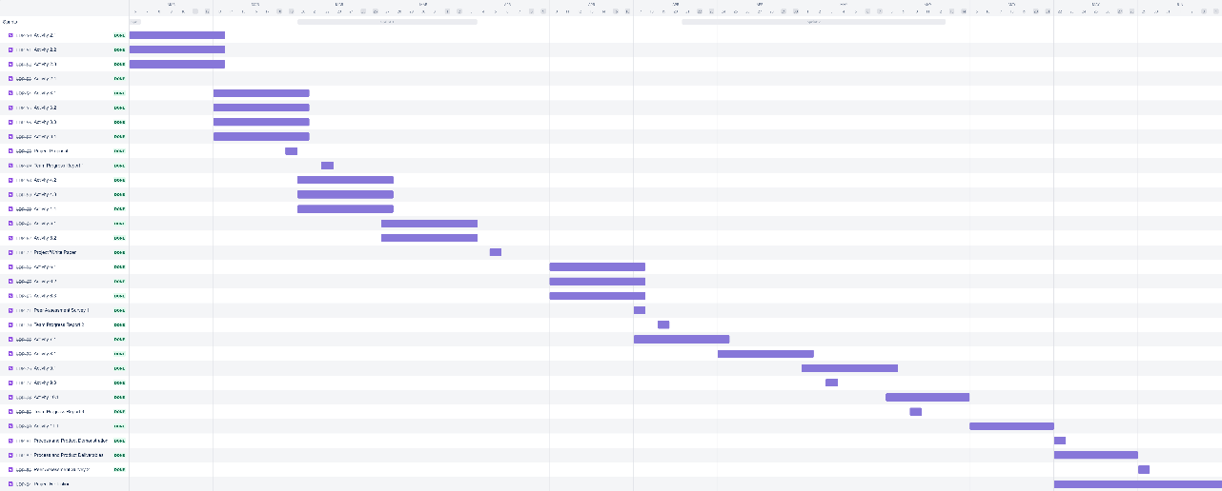
Figure 10: Stannard, R. (2023, May 12). Activity 1.4: Get Started on Scrum (Set Up a Jira Project). Atlassian. https://ict20025ictdesignproject.atlassian.net/jira/software/projects/IJDP/boards/5/roadmap?shared=&atlOrigin=eyJpIjoiNWNiOGMwOWE5NmRmNDNhYzk3M2NjNDAwNWM2Y2Y1MTIiLCJwIjoiaiJ9

4.3. ULO 3
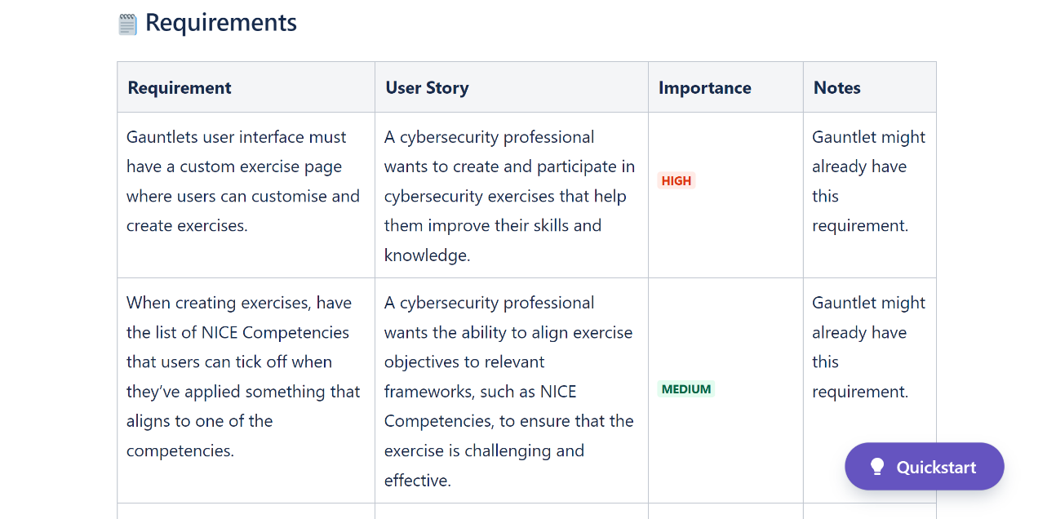
Figure 11: Stannard, R. (2023, May 12). Activity 2.4: Empathise and Define – User Stories. Atlassian. https://ict20025designproject.atlassian.net/l/cp/u1HYLHTq

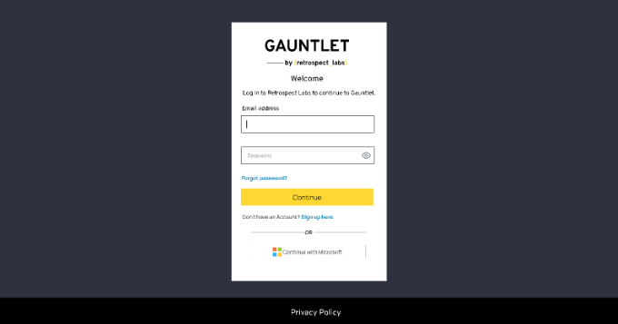
Figure 12: Stannard, R. (2023, May 20). Final Prototype. Figma. https://www.figma.com/file/CXYqnhacgTb1HNS2F8ijoT/Finished-Prototype?type=design&node-id=1%3A2&t=NKjn2PkY0O3UZApE-1

4.4. ULO 4

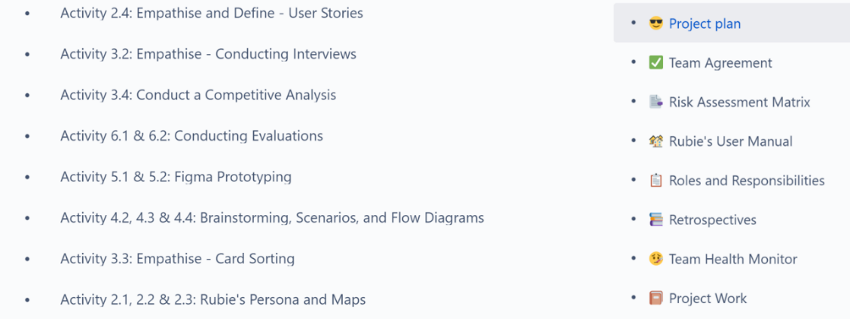
Figure 13: Stannard, R. (2023, May 12). Communicating and Sharing the Project Deliverables with the Team Through Confluence. Atlassian. https://ict20025designproject.atlassian.net/wiki/spaces/IDP1/overview?homepageId=12550351

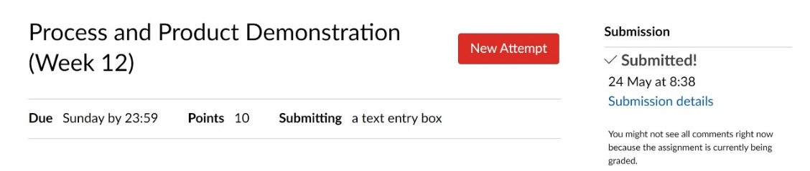
Figure 14: Communicating and Sharing the Project Deliverables with the Facilitator Through Canvas.

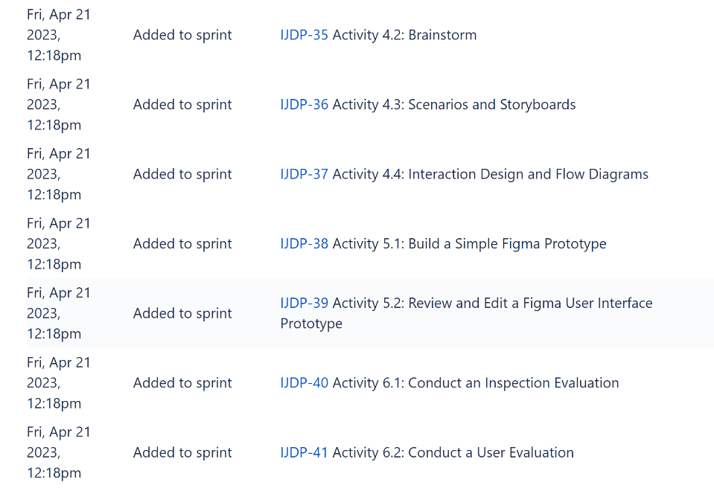
Figure 15: Stannard, R. (2023, May 12). Communicating and Sharing the Project Deliverables with the Team Through Jira. Atlassian. https://ict20025ictdesignproject.atlassian.net/jira/software/projects/IJDP/boards/5/roadmap?shared=&atlOrigin=eyJpIjoiYjVkMTc1NDM0MjllNGUxZGJjN2I5MWQ2Mzk2MjE4YTkiLCJwIjoiaiJ9

4.5. ULO 5
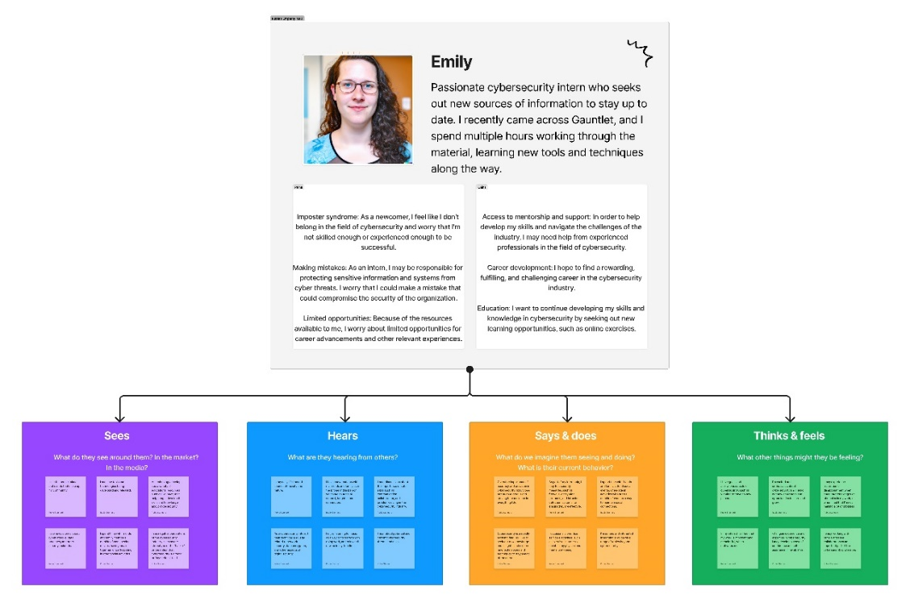
Figure 16: Stannard, R. (2023, March 27). Activity 2.2: Empathise and Define – Empathy Mapping. Figma. https://www.figma.com/file/0mjYOm2FlTVhCVpEW9jFVs/Activity-2.2%3A-Empathise-and-Define---Empathy-Mapping?type=whiteboard&node-id=0%3A1&t=h2hW8Iv5utOeTwua-1

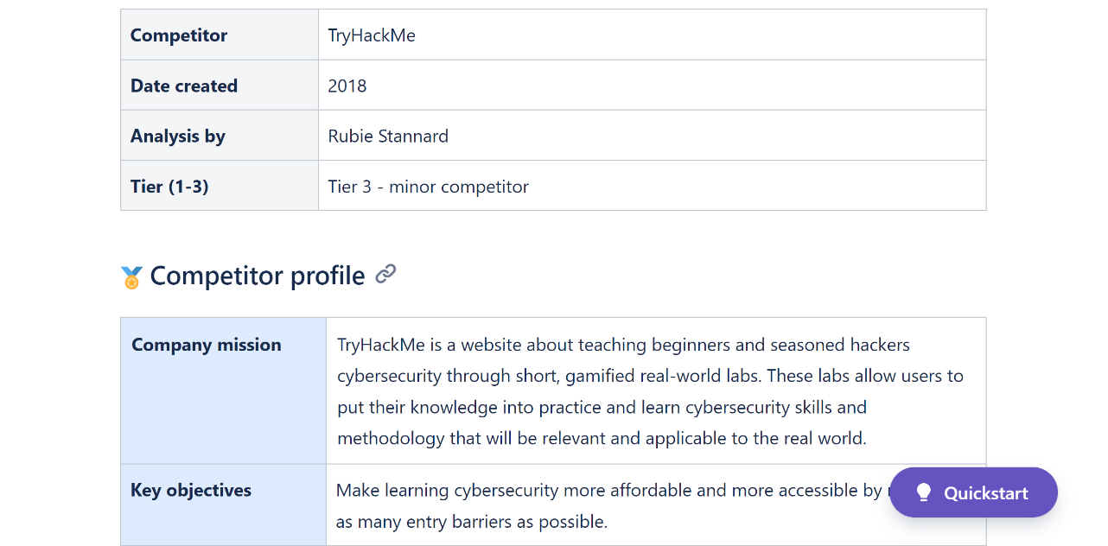
Figure 17: Stannard, R. (2023, May 7). Activity 3.4: Conduct a Competitive Analysis (Optional). Atlassian. https://ict20025designproject.atlassian.net/l/cp/RAEtwf4J

4.6. ULO 6

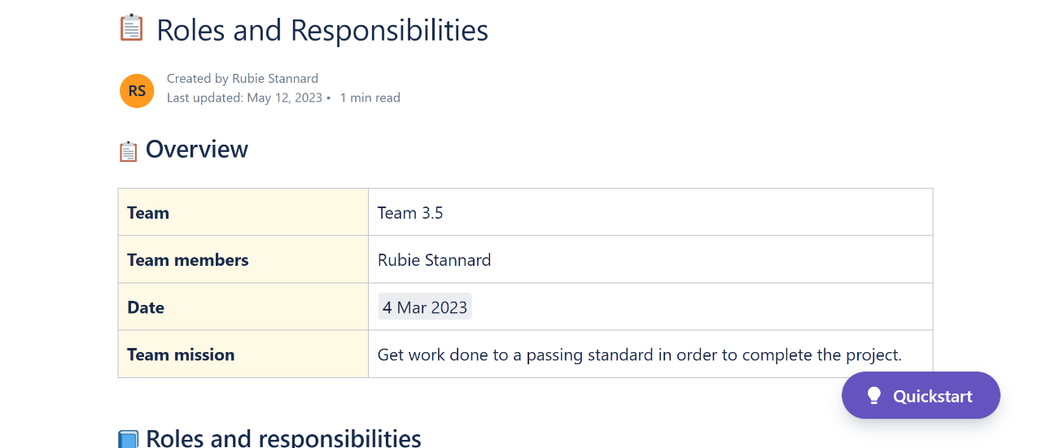
Figure 18: Stannard, R. (2023, May 12). Confluence Space Roles and Responsibilities. Atlassian. https://ict20025designproject.atlassian.net/l/cp/Y43d8ura

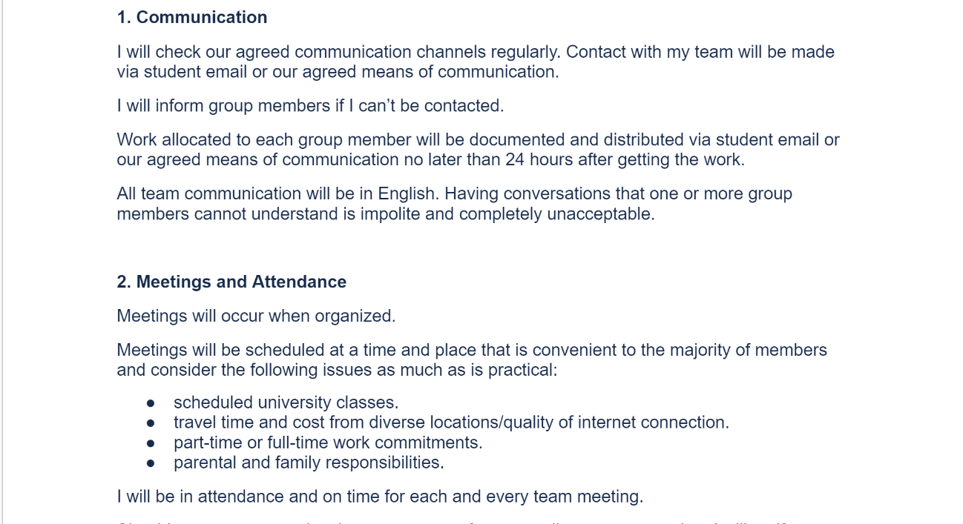
Figure 19: Stannard, R. (2023, May 12). Activity 1.3: Set up your Team Agreement. Google Docs. https://docs.google.com/document/d/14gUkztiAOpQTBsMMiKrS5Mmjv558vWW_lipw3l9AvXc/edit?usp=sharing

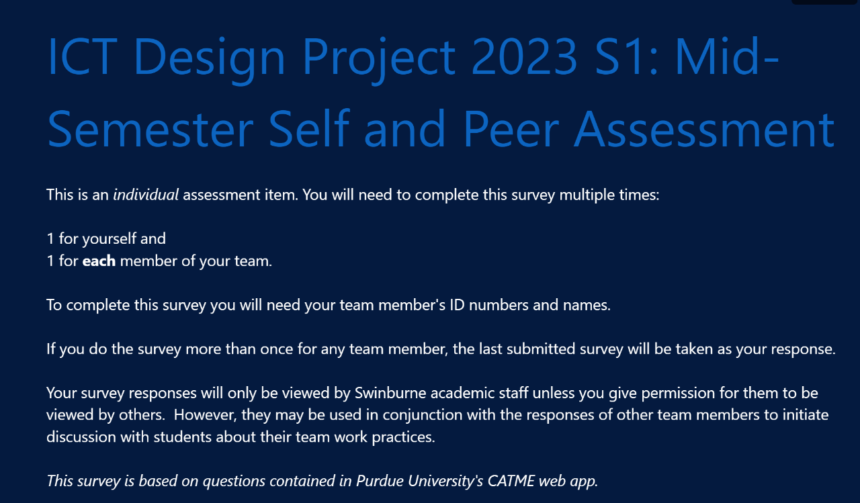
Figure 20: Peer Assessment Survey 1.

References
Dam, R. F. (2022, June 29). The 5 Stages in the Design Thinking Process. Interaction Design Foundation. https://www.interaction-design.org/literature/article/5-stages-in-the-design-thinking-process
ICT Design Project. Swinburne University of Technology. (n.d.). https://www.swinburne.edu.au/study/courses/units/ICT-Design-Project-ICT20025/local
Swinburne University of Technology. (n.d.). ICT Design Project 2023 S1: Mid-Semester Self and Peer Assessment. Microsoft Forms. https://forms.office.com/Pages/ResponsePage.aspx?id=eXV_35w-fkq4REICgPU4WciLPIp900RKi6PJTNORTp1UQThOWEpRMDhaTzNWUDg1ODNRRUVPSEFRVC4u

